40.10: 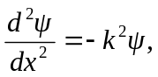 and for to be a solution of Eq.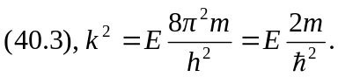
b) The wave function must vanish at the rigid walls; the given function will vanish at for any 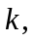 but to vanish at 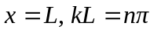for integer

